API Searches

* Flight Data API Documentation
* Travelpayouts Data API – the way to get travel insights for your site or blog. Get flight price trends and find popular destinations for your customers.
* <https://english.api.rakuten.net/Travelpayouts/api/flight-data>
* Endpoints
  + Non Stop Tix
  + Popular directions from city
  + Popular Airline Routes
  + Cheapest Tix
  + Cheapest Tix by month
  + The calendar of prices for a month
  + Special offers
  + The calendar of prices for a week
  + Airline data in json format (x3)
  + City data in json format
  + Data of countries in json format
  + Data of countries in json fromat
* Priceline.com API Documentation
* Real time Priceline API: Car Rentals, Hotels, Flights.
* <https://rapidapi.com/davidtaoweiji/api/priceline-com?endpoint=apiendpoint_ea584354-44eb-44fc-ab45-114b83b3ac8c>
* Endpoints
  + Hotel Details
  + Hotel city search
  + Hotel city Nearby
  + Hotel list
* Hotels.com FREE API Documentation
* Real time Hotels.com prices, reviews, meta data
* <https://rapidapi.com/yahoo.finance.low.latency/api/hotels-com-free>
* Endpoints
  + Suggest
  + Details
  + Search Nearby
  + Reviews
* Trip Purpose Prediction API Documentation
* Understand the reason for a trip with Amadeus AI APIs. The Trip Purpose Prediction API uses AI trained on Amadeus historical trip booking data to predict whether a given itinerary is for a business trip or a vacation. Provide travelers with a personalized experience by understanding their motivations.
* <https://rapidapi.com/amadeus-for-developers-amadeus-for-developers-default/api/trip-purpose-prediction2>
* Best Booking.com Hotel API Documentation
* Fetch the best booking.com hotel in town
* <https://rapidapi.com/PlanYourTrip/api/best-booking-com-hotel>

Applied

* Sygic Travel API
* The Sygic Travel API offers global tourism and travel data available as a consumable database. Over 20 million places from around the world are available. The places are ranked by popularity among travelers. Information such as location, description, photos, admission fees, tags and opening hours is offered from the API in 18 languages. Points of interest are matched to relevant tours and activities which can be offered to end-customers in order to earn ancillary revenue. Tourism businesses can benefit from the Sygic Travel API by building trip planner and travel guide integrations.
* <http://docs.sygictravelapi.com/1.1/>
* Priceline

Top USA 10 Summer and Winter

* <https://travel.usnews.com/rankings/best-summer-vacations-in-the-usa/>
* <https://travel.usnews.com/rankings/best-winter-vacations/>

\*\*NOTE we can utilize our news API for this potentially\*\*

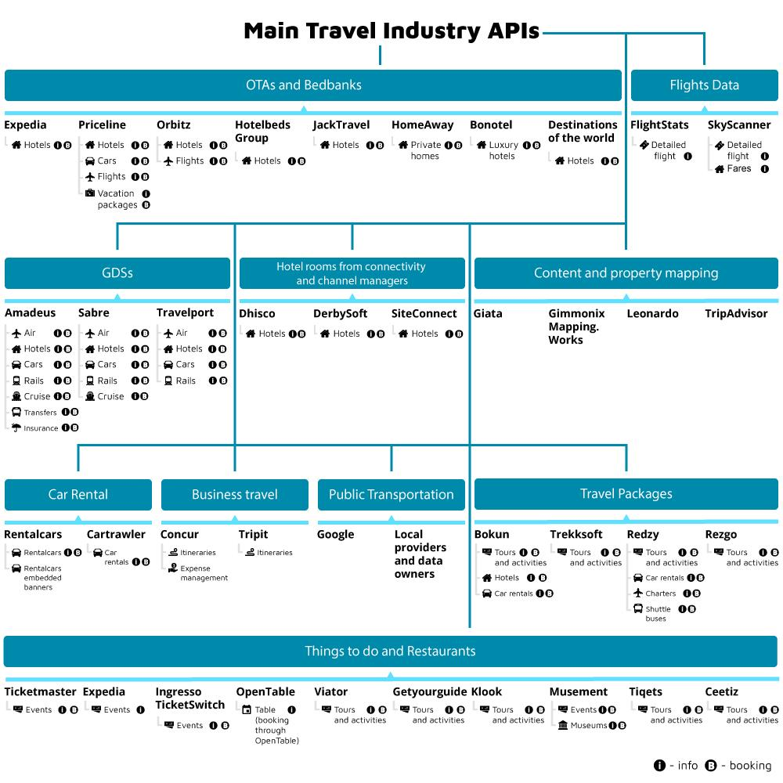

https://www.altexsoft.com/blog/engineering/travel-and-booking-apis-for-online-travel-and-tourism-service-providers/